Original Tittle : A Bluetooth-Based Attendance System for Educational Administration: Cross-Platform Development and Experimental Validation
Revised : A Bluetooth-Based Attendance System for Educational Administration at SMA Muhammadiyah: Cross-Platform Development and Usability Validation
Muhyddin A.M. Hayat¹, Muhammad Fachri Rasyidi^{2*}, Muhammad Faisal³, Rizki Yusliana Bakti⁴, Andi Makbul Syamsuri⁵
^{1, 2, 3,4,5}Department of Informatics, Universitas Muhammadiyah Makassar, Indonesia

*Corresponding author: ² 105841106320@unismuh.ac.id
Received : Jun 9, 2025; Revised : Nov 20, 2025; Accepted : Nov 22, 2025; Published : Dec 11, 2025
Phone Number : +62 822-3943-7989

Abstract
The transformation of educational administration through technology has accelerated significantly, particularly in attendance systems, which have traditionally relied on manual roll calls. These conventional methods are time-consuming, error-prone, and susceptible to manipulation. This study presents a novel Bluetooth-based attendance system that contributes to the field by demonstrating passive MAC address detection for automated attendance recording, eliminating the need for additional software installations on student devices. The system was developed using React Native for cross-platform compatibility, with PostgreSQL for data management and NestJS for backend processing. The software engineering process followed Rapid Application Development (RAD) methodology, combined with comprehensive system validation through experimental testing. Usability evaluation with 133 participants using the System Usability Scale (SUS) yielded a score of 79.85, categorizing the system within the "Good to Excellent" usability range. The findings demonstrate significant improvements in efficiency and a reduction in attendance fraud compared to conventional methods. However, hardware quality and device proximity remain key limitations. Future research should explore the integration of Bluetooth Low Energy (BLE) technology, the implementation of machine learning algorithms for anomaly detection, or the development of hybrid validation models that combine multiple authentication factors. This system demonstrates the potential to modernize educational administration through seamless, device-level integration while maintaining high user acceptance.

Keywords: Bluetooth attendance system, Educational technology, Mobile application, Software engineering, System usability scale.

This work is an open access article and licensed under a Creative Commons Attribution-Non Commercial 4.0 International License

- INTRODUCTION
Education and technology are two fundamental pillars in shaping the modern learning ecosystem [1]. The integration of digital innovation into educational systems has driven significant transformations, particularly in academic administration processes such as attendance tracking [2]. As technology becomes increasingly embedded in all aspects of life, technological leadership within educational institutions is crucial to ensuring effective management and improved service delivery [3].
One administrative activity with a high potential for digital improvement is attendance monitoring. Conventional methods, such as roll calls or manual sign-in sheets, typically require a considerable amount of time, are prone to recording errors, and leave the possibility of manipulation open [4]. Previous research emphasized that the student community, characterized by its large population and relatively low self-management, requires accurate attendance management systems to prevent widespread absenteeism and instructional disruptions [5]. As information technology has advanced, electronic attendance systems have been gradually adopted by higher education institutions [6]. Class attendance is widely acknowledged as a key determinant of academic achievement [7]. Many institutions use attendance records as an indicator of student discipline and as a tool for encouraging engagement in academic activities [8]. Attendance data is also often used to evaluate instructional effectiveness, institutional accreditation, and behavioural assessment systems [9].
Although manual methods remain prevalent, they have numerous limitations, including the need for extensive manual intervention, susceptibility to human error, and the potential for dishonest practices such as proxy attendance [10]. In response to these limitations, the adoption of technology presents a promising solution. Bluetooth technology offers significant advantages in terms of energy efficiency and device compatibility [11]. By leveraging this technology, the attendance process can be conducted automatically and in real-time using students' devices, which are connected to the system via Bluetooth [12]. One such innovation is the use of Bluetooth-based attendance systems. Bluetooth is a short-range, low-energy wireless communication protocol originally developed as an alternative to cables [13].
Previous studies have examined the development of digital attendance systems using various technologies. For example, facial recognition systems have demonstrated high levels of accuracy using deep learning models such as ResNet-50 and VGG-16 [14]. Fingerprint-based systems employing biometric scanners and C# programming platforms have also yielded promising results in verifying student attendance [15]. NFC-based systems offer fast and user-friendly interactions, achieving high levels of user satisfaction in previous trials [16]. Similarly, QR code-based systems have proven effective and easy to implement, although they remain susceptible to misuse, such as the unauthorized sharing of codes [17], [18].
This study identifies a significant gap in existing digital attendance solutions and addresses it through a novel approach. While various digital attendance systems have been explored, ranging from facial recognition to NFC, fingerprint, and QR-based solutions, the majority still require additional hardware installations, dedicated mobile applications, or direct manual user intervention, which limits accessibility and scalability [19], [20], [21].
The primary novelty of this research lies in developing a Bluetooth-based attendance system that operates entirely through passive MAC address detection, requiring zero additional software installations on student devices while maintaining real-time automated attendance logging within a defined proximity range. This approach represents a significant advancement over existing solutions by eliminating user-side requirements while enhancing operational transparency and efficiency. Furthermore, the system significantly reduces fraudulent practices such as proxy attendance or code sharing that plague QR-based systems [22], [23]. The contribution extends beyond technical innovation to include comprehensive usability validation through standardized SUS methodology, providing empirical evidence for system acceptance in real-world educational environments.
This study offers a novel approach by designing a Bluetooth-based attendance system that requires no additional app installation on the student's side. It works by detecting the device's MAC address and automatically recording attendance. All records are stored in a structured database and can be accessed in real-time by authorized personnel, enabling timely intervention in cases of absence. For educators, this system reduces administrative burdens, allowing them to focus more on instructional delivery and student engagement [24], [25].
The development of Bluetooth-based attendance systems supports the creation of a more professional, efficient, and technology-adaptive learning environment. When properly implemented, such systems not only enhance the quality of educational administration but also help cultivate a culture of punctuality, responsibility, and engagement among students, essential elements for sustained academic success.
- METHOD
This study employs an experimental approach through information system design, incorporating software engineering principles and comprehensive system validation. The research methodology follows a structured approach as illustrated in the methodology flowchart below, which encompasses system design, development, implementation, and evaluation phases.

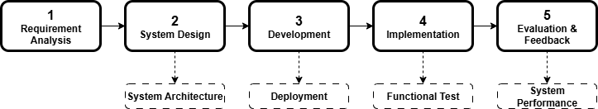
Figure 1. Research Methodology Framework for Digital Attendance System Development

Figure 1 illustrates a systematic five-phase research methodology for developing a digital attendance system. The flowchart demonstrates a sequential approach beginning with Requirement Analysis (Phase 1), followed by System Design with System Architecture considerations (Phase 2), Development including Deployment planning (Phase 3), Implementation with Functional Testing (Phase 4), and concluding with Evaluation & Feedback focused on System Performance assessment (Phase 5). Each phase builds upon the previous one through clear forward progression arrows, while the dashed boxes below each main phase indicate the specific technical activities and deliverables that support the primary objectives of each development stage.
This research approach was chosen to design a digital attendance system using Bluetooth technology that prioritizes user-friendliness and operational efficiency. The study is designed for application across various institutional settings, including educational institutions and corporate environments, for digital attendance management purposes.
  - Data Collection
This study strategically gathered insights to drive the design, implementation, and validation of the Bluetooth-based attendance system, ensuring each stage was informed by real-world context and user interaction. To ensure comprehensiveness, both primary data and system-generated data were utilized:
- Primary Data
Collected through system usage during classroom and laboratory activities involving real student participants. Students voluntarily registered their devices by submitting MAC addresses into the system, enabling them to be detected during attendance sessions.
- System-Generated Data
Automatically recorded by the application backend using the PostgreSQL database. Included device scan logs, time stamps, MAC address matches, class/lab identifiers, and session status (present or absent).
  - Database Design
A comprehensive database schema was created for data management as part of this study's PostgreSQL database design plan. PostgreSQL is an open-source object-relational database management system (ORDBMS) [26]. It supports various indexing methods, including B-Tree, Hash, Generalized Inverted Index (GIN), and Generalized Search Tree (GiST), with the latter also supporting R-tree-over-GiST structures.
The database schema was carefully designed to support the functionality of a Bluetooth-based attendance application developed using React Native. PostgreSQL was chosen as the database management system because of its flexibility, robustness, and support for advanced indexing techniques. PostgreSQL uses B-Tree indexes by default, which work well with all common data types and enable fast equality and range queries. For more complex data types, such as full-text search fields or geometric values, PostgreSQL provides Generalized Search Tree (GiST) indexing capabilities. These features offer opportunities for future system extensions, such as incorporating spatial validation or advanced querying features. The system architecture includes six core relational tables, as illustrated in Figure 2.

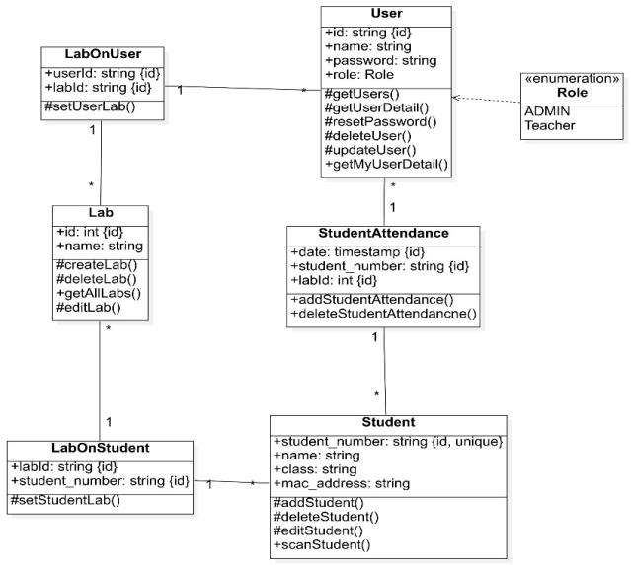
Figure 2. Database Class Diagram

The students table stores students’ identifiers (student_number), class assignments (class), and Bluetooth MAC addresses (mac_address). Student attendance is recorded in the StudentAttendance table, which includes fields such as student_number, lab_id, and date, forming a composite key to ensure each student’s attendance is uniquely registered per laboratory session per day. The latter table enforces access control, ensuring that users' roles are assigned to their assigned laboratories.
This schema provides a clear separation between authentication, access rights, and attendance logic, enhancing modularity and maintainability. Foreign keys and composite indices are implemented to maintain data integrity and ensure efficient query performance. Overall, this database design ensures scalability, supports secure role-based access, and facilitates seamless communication between the frontend (React Native) and backend server (NestJS), which interacts with the database through RESTful APIs.
  - Application Development Scenario
The system utilizes the React Native framework, which enables the development of cross-platform mobile applications using a single codebase. The integration of a comprehensive library of reusable components facilitates accelerated development, while the framework's support for native modules allows it to deliver performance that closely approaches that of fully native applications. To support a faster and more standardized development process, this system also utilizes Expo, a framework that simplifies the development of Android and iOS apps [27]. Expo abstracts many complex configurations and provides direct access to hardware features such as cameras, sensors, and Bluetooth, which are particularly relevant in this system's context.
NestJS, a framework for building efficient and scalable server-side applications with Node.js, is used to develop the system's backend. NestJS incorporates concepts from object-oriented programming, functional programming, and functional reactive programming paradigms, utilizes modern JavaScript features, and is built entirely with TypeScript [28]. NestJS is responsible for managing attendance tracking, student and device data management, implementing security for teacher accounts, and handling the enrollment process to manage duplicate data. The device usage scenario follows these phases:
- Registration
In the initial stages of using the application, users are required to authenticate through the login page by entering their email address and password. After successful login, the system verifies the user account role. Once a device option is selected, the system retrieves the device's physical address (MAC address) and sends the data along with information from the previous form to the server for processing and storage in the database. The process illustration is shown in Figure 2.
- Attendance recording
During the attendance process, the system scans devices via Bluetooth, matches the detected MAC addresses with registered data, and automatically records attendance. This scanning process runs continuously, allowing users to stop scanning by pressing the same button. Students detected through devices found via the user's Bluetooth are collected in a single session and sent to the server. After successful data processing, the student's attendance status changes from "Not Attending" to "Attending". The process illustration is shown in Figures 3 and 4.

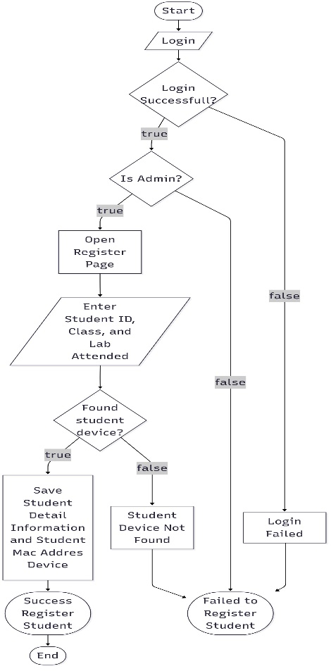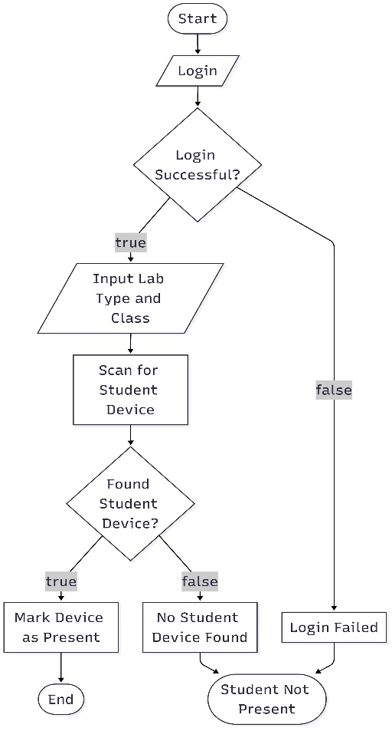
Figure 3. Registration Process Flowchart Figure 4. Attendance Recording Flowchart

This structured two-step process simplifies attendance management by minimizing manual intervention, enhancing data accuracy, and ensuring that only authorized users can perform attendance-related actions. The interaction between user roles, Bluetooth scanning, and backend processing demonstrates a practical implementation of proximity-based automation in an academic setting.
  - System Evaluation Using SUS
To ensure comprehensive system validation, this study employs the System Usability Scale (SUS) as the primary evaluation framework, utilizing this widely accepted standardized tool that consists of 10 statements rated on a 5-point Likert scale to measure perceived usability. The evaluation process involved recruiting 133 participants from active laboratory users who had direct interaction with the system, with each participant completing the SUS questionnaire after using the system for both attendance registration and recording processes. SUS scores were calculated using the standard formula, with final scores ranging from 0 to 100, followed by a comprehensive statistical analysis including distribution analysis, correlation studies, and comparative evaluations to assess system performance and user satisfaction. This SUS evaluation framework provides objective metrics for system usability while simultaneously identifying areas for improvement and validating the system's readiness for broader deployment in educational environments.
  - Proposed Framework
Bluetooth Classic (BTC) operates in the 2.4 GHz ISM band, utilizing an 80 MHz bandwidth across 79 channels, each 1 MHz wide and spaced 1 MHz apart. Channel centre frequencies are defined by f k ​ =(2402+k) MHz, where k∈[0,78]. The physical layer utilizes GFSK modulation for Basic Rate (BR) transmissions, achieving a data rate of 1 Mbps. Enhanced Data Rate (EDR) modes, on the other hand, employ π/4-DQPSK or 8DPSK, achieving up to 2 or 3 Mbps, respectively. The symbol rate is 1 Msym/s. Each channel is divided into 625 µs time slots, and BTC uses adaptive frequency hopping to mitigate interference and fading. BTC packets, lasting 1 to 5 time slots, are synchronized with these 625 µs intervals [29].
Bluetooth Classic was chosen because it has a higher level of compatibility with a wide range of devices compared to Bluetooth Low Energy (BLE), especially in terms of connection stability and the ability to recognize devices based on Media Access Control (MAC) that used as the unique identity of the devices associated with each device [30]. An illustration of the Framework is shown in Figure 5.

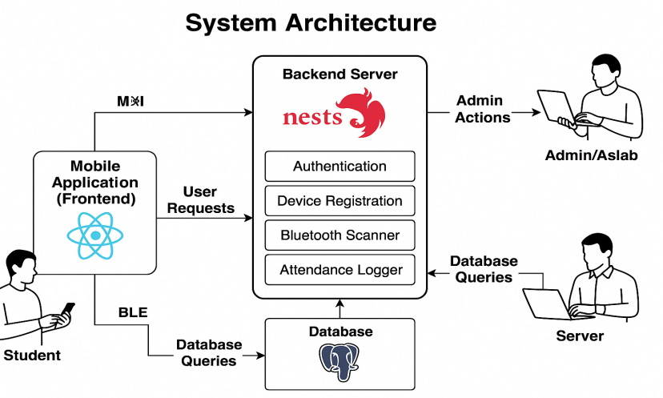
Figure 5. Proposed System Framework

This diagram illustrates the attendance system architecture consisting of three main components: Frontend (Mobile Application), Backend Server (NestJS), and Database (PostgreSQL), as well as the main actors: Student and Lab Admin.
- RESULT
  - Application Interface
The developed Bluetooth-based attendance system features a responsive and intuitive main interface. The main page includes device registration features, class and laboratory form completion, and a "Scan" button to perform the attendance detection process. On this page, users can immediately start the attendance process by accessing nearby Bluetooth devices. The interface is configured according to the authenticated user's role in the system. The user registration interface, designed for streamlined device enrollment and user authentication, is shown in Figure 6.
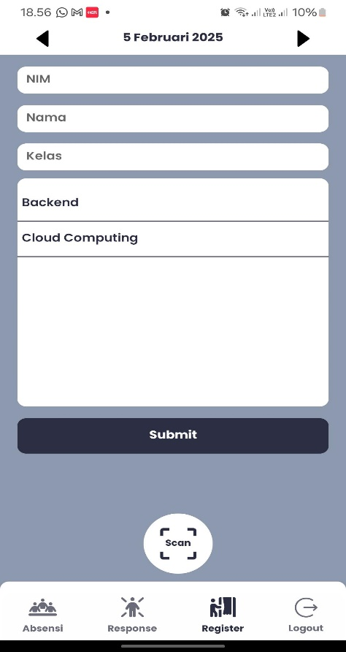
Figure 6. Registration Form
  - Student Attendance Recording Feature
As illustrated in the "Attendance Recording" feature, users first complete the class and laboratory-type information form, as shown in Figure 7 (A). After data entry, the list of students who are laboratory members is displayed, complete with their names, Bluetooth MAC addresses, and attendance status. Students who have not been recorded are marked with "Not Attending" status in red, while students successfully detected by the system have their status changed to "Attend" in green.
The recording process occurs automatically through Bluetooth scanning. After pressing the Scan button, the system searches for nearby student devices based on their MAC addresses, as shown in Figure 7 (B). Scan results are sent to the server, which then verifies and stores the attendance data. The system also performs automatic screening to prevent duplicate recording.

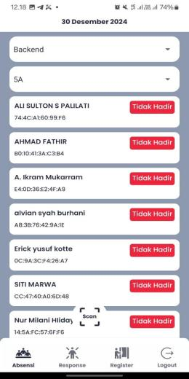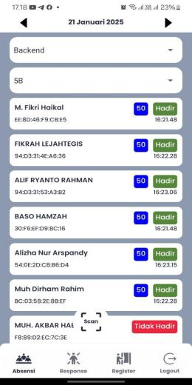
(A) (B)
Figure 7. Attendance Recording Interface: (A) Pre-scanning device detection status, (B) Post-scanning attendance confirmation results
  - Database Structure and Data Analysis
The database improvement tool in this study employs Dbeaver, which is a free and open-source, widely used database tool for developers and database administrators [31].
    - Lab Table Analysis
Table 1 displays the contents of the Lab table, which contains two entries: "Backend" and "Cloud Computing". This configuration reflects the focused testing environment for two specific laboratories. While the number of entries is limited for this pilot study, the table structure supports scalable relationships with other tables, such as LabMahasiswa and LabOnUser, ensuring data integrity in multi-role systems and facilitating future expansion to additional laboratory environments.
Table 1. Lab Table
Id | Name
1 | Backend
2 | Cloud Computing

    - Students Table
Table 2 presents the contents of the students’ table, recording 80 student entries registered in the system. This represents a substantial sample size for system validation, though it specifically focuses on students actively involved in Backend and Cloud Computing laboratories. The data distribution across different class sections (5A, 5B, 5C, 5D) provides comprehensive coverage for testing system functionality across various student groups.
Table 2. Students Registration Database Entries
No | Student Number | Name | Class
1 | 105841105522 | M. Fikri Haikal | 5B
2 | 105841105322 | Fikrah Lejahtegis | 5B
3 | 105841104222 | Alif Ryanto Rahman | 5B
4 | 105841114422 | Muhammad Alif Syafan | 5D
5 | 105841109822 | Dayang Aisyah | 5C
6 | 105841106922 | Baso Hamzah | 5B
7 | 105841110622 | Wa Nanda Sulystrian | 5C
8 | 105841106722 | Alizha Nur Arspandy | 5B
9 | 105841102222 | Ali Sulton S Palilati | 5A
10 | 105841105622 | Muh Dirham Rahim | 5B
11 | 105841102622 | A. Ikram Mukarram | 5A
12 | 105841104622 | Muh. Akbar Haeruddin | 5B
13 | 105841105822 | Muh. Ilham Akbar | 5B
14 | 105841103522 | Alvian Syah Burhani | 5A
15 | 105841101922 | Erick Yusuf Kotte | 5A
16 | 105841100122 | Siti Marwa | 5A
17 | 105841100822 | Nur Milani Hiidayah | 5A
18 | 105841100722 | Nabila Ismail Matta | 5A
19 | 105841100422 | Ferdiansyah | 5A
20 | 105841100322 | Fajar Eka Alamsyah | 5A
.. | .. | .. | ..
80 | 105841112122 | Annisa Alfrini | 5D

    - Student Attendance Table
Table 3 illustrates the student attendance records, containing 302 entries recorded during the approximately 8-week testing period. This substantial data volume demonstrates consistent system usage and reliable attendance tracking. The predominance of labId = 1 entries indicates primary testing occurred in the Backend laboratory, while the Cloud Computing laboratory (labId = 2) shows lower activity levels, reflecting the phased implementation approach adopted during the validation period.
Table 3. Attendance Records Analysis
No | LabId | Student Number
1 | 2 | 105841105522
2 | 1 | 105841105522
3 | 2 | 105841105322
4 | 1 | 105841105322
5 | 2 | 105841104222
6 | 1 | 105841104222
7 | 2 | 105841114422
8 | 1 | 105841114422
9 | 2 | 105841109822
10 | 1 | 105841109822
11 | 2 | 105841106922
12 | 1 | 105841106922
.. | .. | ..
160 | 1 | 105841107222

The comprehensive data collection reveals consistent system performance with minimal errors, supporting the viability of Bluetooth-based attendance tracking in educational environments.
- discussion
  - Effectiveness of Implementing the Bluetooth-Based Attendance System
The Bluetooth-based attendance system demonstrated high effectiveness in automating attendance recording within a university laboratory environment. By utilizing MAC addresses as unique identifiers for devices, the system enables real-time presence detection without requiring manual user interaction. According to data from the Student Attendance table, the system successfully recorded over 300 attendance entries across two active laboratories during the trial period. This indicates consistent system operation with minimal errors in detecting student devices. Compared to conventional attendance methods—such as signature sheets or roll calls—this approach significantly saves time, reduces administrative errors, and minimizes potential fraudulent practices, including proxy attendance.
  - System Usability Evaluation Using SUS
The system's viability and user-friendliness were evaluated using the System Usability Scale (SUS) [32], a widely accepted standardized tool for measuring perceived usability. A total of 133 participants were involved in the evaluation after direct interaction with the system. The SUS comprises 10 statements, each rated on a 5-point Likert scale, which are combined to generate an overall usability score between 0 and 100. In this evaluation, the system achieved an average SUS score of 79.85, placing it within the "Good to Excellent" usability category.
This score indicates that most users perceived the system as easy to use, efficient, and cognitively lightweight. These findings align with the system's simple interface design, intuitive auto-scan feature, and the absence of additional installation requirements on the user side.
Despite overall positive results, a small number of participants reported minor detection issues related to MAC address randomization on certain devices, as well as signal interference between adjacent laboratory environments. However, these issues had no significant impact on the overall SUS score. Such findings offer valuable insights for future development, including the incorporation of hybrid validation mechanisms or geofencing integration to improve device detection accuracy and enhance user experience.
Table 4 contains all questions asked of students regarding their satisfaction level with the Bluetooth attendance system.

Table 4. System Usability Scale (SUS) Questionnaire Items for User Satisfaction Assessment
No | Questions
1 | I am considering using this system again (Saya mempertimbangkan untuk menggunakan sistem ini lagi).
2 | I feel that this system is complicated to use (Saya merasa bahwa sistem ini rumit untuk digunakan).
3 | I feel that this system is easy to use (Saya merasa bahwa sistem ini mudah untuk digunakan).
4 | I need help from someone else when using this system (Saya memerlukan bantuan dari orang lai saat menggunakan sistem ini).
5 | I believe that the features in this system are working as they should (Saya percaya bahwa fitur-fitur dalam sistem ini berfungsi sebagaimana mestinya).
6 | I think there are a lot of elements in this system that are less consistent (Saya pikir ada banyak elemen dalam sistem ini yang kurang konsisten).
7 | I believe others will be able to learn to use this system quickly (Saya percaya orang lain akan dapat belajar menggunakan sistem ini dengan cepat).
8 | I feel that this system is confusing (Saya merasa bahwa sistem ini membingungkan).
9 | I feel that there are no obstacles in using this system (Saya merasa tidak ada hambatan dalam menggunakan sistem ini).
10 | I have to familiarize myself with this system before using it (Saya harus membiasakan diri terlebih dahulu dengan sistem ini sebelum menggunakannya).

The System Usability Scale (SUS) was utilized to determine user satisfaction with the system among students in a laboratory learning environment. As one study states, the SUS has become a popular questionnaire to include in surveys. The conventional method for calculating SUS scores can be somewhat complex, primarily due to the alternating phrasing of questionnaire items and an early design choice to normalize the final score on a 0–100 scale. The SUS comprises a 10-item questionnaire, with each item rated on a 5-point Likert scale [33]:
1 = Strongly Disagree, 5 = Strongly Agree
Steps to Calculate the SUS Score:
- Scoring each item:
- For odd-numbered items (1, 3, 5, 7, 9): $\text{Score}=\text{User response}-1$
- For even-numbered items (2, 4, 6, 8, 10): $\text{Score}=5-\text{User response}$
- Sum the adjusted scores from all 10 items..
- Multiply the total raw score to get the final SUS score:

$SUS Score=\left(Total Raw Score\right) x 2.5$ (1)

A referenced study outlines several categorical levels for interpreting SUS scores, which include: 1 – Worst imaginable (n = 1), 2 – Awful (n = 0), 3 – Poor (n = 15), 4 – OK (n = 36), 5 – Good (n = 90), 6 – Excellent (n = 69), and 7 – Best imaginable (n = 1) [34]. The average SUS scores corresponding to categories 3 through 6 (where n ≥ 15) were approximately 39, 52, 73, and 86, respectively, after rounding. Additionally, the study employed an absolute grading scale: A for scores between 90–100, B for 80–89, C for 70–79, D for 60–69, and F for scores below 60. With a score of 79.85, the system falls into a high grade, reinforcing the perception that the system is well-designed and user-friendly, though still open to further refinement. The SUS Score Distribution from 133 participants is illustrated in Figure 8.

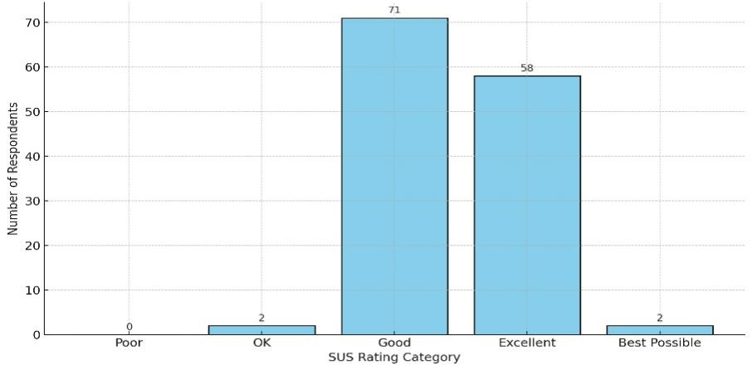
Figure 8. Distribution Analysis of SUS Scores from 133 Participants Showing User Satisfaction Patterns

To evaluate the distribution and consistency of user perceptions toward the system, a boxplot visualization (Figure 10) of the SUS scores was conducted to identify potential outliers and the interquartile range as indicators of user experience stability. Furthermore, system stability during the implementation phase was analyzed through a daily trend visualization (Figure 9). The daily average SUS scores were simulated to observe whether fluctuations in user perception occurred over time. Finally, to assess the impact of user interaction duration on perceived system usability, a correlation analysis was performed between usage time and SUS scores. A scatter plot illustrates the linear relationship, accompanied by a regression trend line.

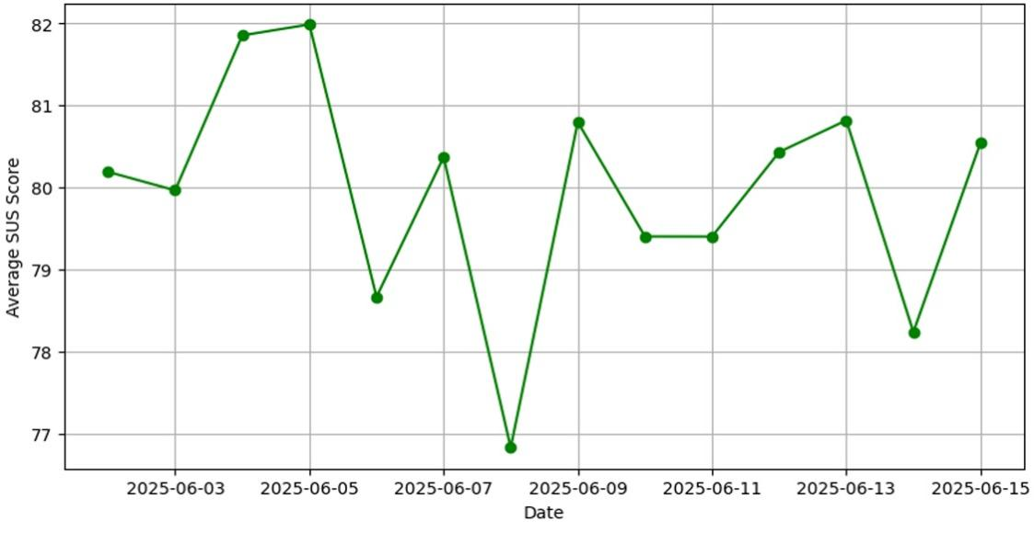
Figure 9. Temporal Analysis of Daily Average SUS Scores Showing System Consistency Over Time

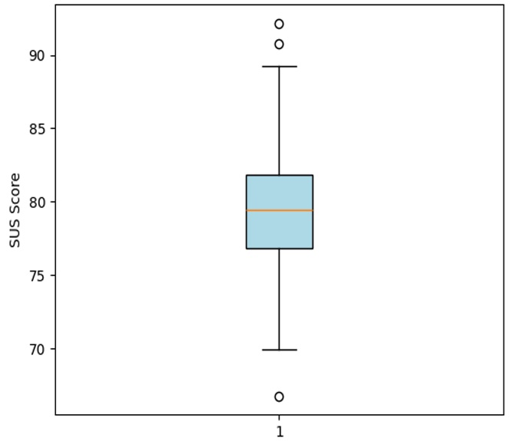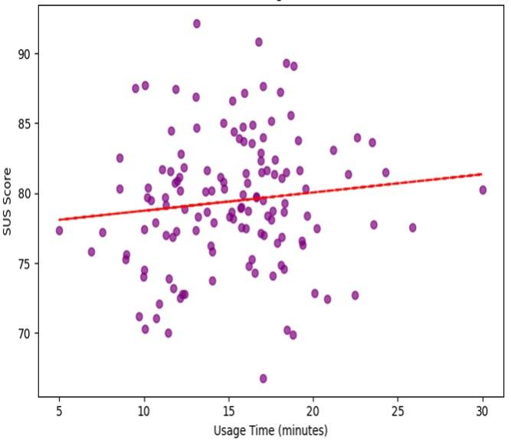
Figure 10. SUS Score Distribution Figure 11. Correlation Analysis Between
Boxplot Analysis System Usage Time and SUS Scores

This demonstrates the system's consistency over time and user sessions, implying reliability in real-world conditions. Furthermore, a scatter plot analysis revealed a weak positive correlation between system usage time and SUS score (Figure 11), suggesting that extended interaction with the application may enhance users' appreciation and satisfaction. These findings collectively reinforce the efficacy of the Bluetooth-based attendance system in providing a highly usable and well-accepted solution. The visual evidence from multiple statistical perspectives supports the robustness of the system’s design, contributing to both user acceptance and administrative efficiency in academic settings.
  - Comparative Analysis with Existing Attendance Systems
Compared to other attendance methods documented in recent literature, this system demonstrates superior performance across various dimensions. While facial recognition systems using ResNet-50 and VGG-16 models achieve high accuracy rates, they require sophisticated hardware and are susceptible to lighting conditions and privacy concerns. Fingerprint-based systems provide excellent security but necessitate dedicated biometric scanners and individual enrollment processes. NFC-based solutions offer rapid interaction but require physical proximity and specialized hardware infrastructure.
As shown in the comparative analysis in Figure 12, the Bluetooth-based system achieved the highest scores in time efficiency, automation level, and fraud resistance. Unlike QR code systems, which still require active interaction from students and remain vulnerable to code sharing [38], this system operates passively and only records attendance from devices physically within Bluetooth range, effectively eliminating fraudulent check-in opportunities.

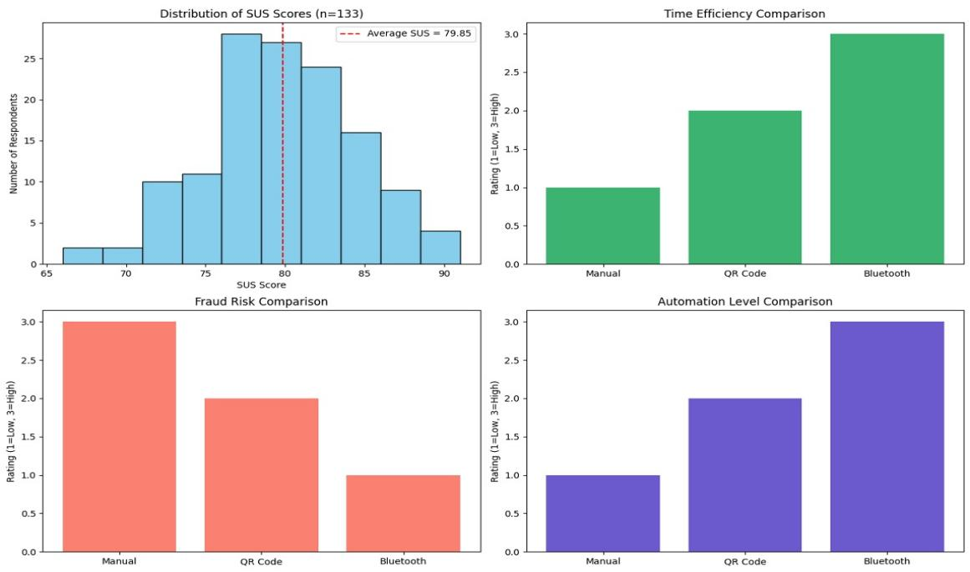
Figure 12. Multi-Dimensional Comparative Analysis of Attendance System Performance Metrics

Based on the test results presented in the graph, the following insights were obtained:
- SUS Score Distribution
The histogram shows the distribution of SUS scores from 133 respondents, with an average of 79.85, which is included in the "Good to Excellent" category. This signifies the system is very easy to use and accepted by users.
- Time Efficiency Comparison
The Bluetooth-based attendance system received the highest score (3), compared to manual methods and QR codes. This shows significant efficiency in attendance recording time.
- Fraud Risk Comparison
Bluetooth poses the lowest risk level (1) as it only detects physical devices that are actually present. Manual attendance is highly susceptible to proxy attendance (3), while QR code-based methods fall in the middle risk category (2).
- Automation Level
The Bluetooth-based system provides full automation (3), requiring no user intervention during the attendance process. In contrast, QR code-based methods require manual scanning by users, while manual attendance relies entirely on conventional record-keeping.
  - System Limitations and Future Research Directions
While the system demonstrates considerable promise, several limitations warrant attention. The system currently lacks geospatial awareness, which can potentially cause Bluetooth signal overlap in adjacent classrooms or laboratories, resulting in erroneous presence detection. Additionally, the current design relies solely on MAC address verification, which, although unique, does not guarantee user identity without secondary validation layers. Future research should explore several promising directions:
- Bluetooth Low Energy (BLE) Integration
Implementing BLE technology could reduce power consumption while maintaining detection accuracy, which is particularly beneficial for battery-powered devices.
- Machine Learning Enhancement
Developing anomaly detection algorithms could help identify unusual attendance patterns, such as devices consistently detected from improbable locations or rapid changes in presence.
- Hybrid Authentication Models
Combining MAC address detection with secondary validation methods (biometric confirmation, location verification, or time-based tokens) could enhance security without compromising user experience.
- Geofencing Implementation
Integrating GPS-based location verification could prevent cross-classroom attendance recording and improve spatial accuracy.
- Privacy-Preserving Techniques
Exploring cryptographic approaches to device identification that maintain privacy while ensuring unique detection.
  - Academic Implications and Future Development Directions
From an educational management perspective, this system functions not only as a digital attendance tool but also as an instrument for enhancing accountability and operational efficiency. Automatically stored attendance data can be integrated into reporting systems, behavioral attendance analysis, and early warning systems for identifying at-risk students. The system's scalability potential extends to multi-campus institutions, corporate training programs, and large-scale conference management, demonstrating broad applicability beyond the initial academic context.

- CONCLUSION
This paper presents a comprehensive Bluetooth-based attendance system developed using React Native, which automates attendance recording through passive MAC address detection, resulting in significant improvements in efficiency and fraud prevention compared to traditional methods. Experimental validation with 133 participants using the System Usability Scale (SUS) yielded a score of 79.85, indicating "Good to Excellent" usability and high user satisfaction, while the robust NestJS-PostgreSQL architecture ensures scalable institutional deployment. Despite acknowledged limitations, including a lack of geospatial awareness and reliance on single-factor MAC address verification, the system demonstrates viable innovation for educational digitalization. Future research directions encompass BLE integration, machine learning anomaly detection, hybrid authentication models, and geofencing capabilities to enhance spatial accuracy and security. The results confirm that this Bluetooth attendance solution provides a practical and user-accepted framework for modern educational institutions seeking automated administrative workflows, with design principles applicable across diverse organizational contexts that require efficient attendance management systems.

CONFLICT OF INTEREST
The authors state that they have no competing interests concerning the content of this paper.

ACKNOWLEDGEMENT
The authors appreciate the Department of Informatics, Universitas Muhammadiyah Makassar for providing the necessary resources and facilities.

REFERENCES
[1] B. Bervell, J. K. Armah, D. O. Mireku, N. A. P. Sarpong, and N. Annamalai, “Behavioural intentions toward information communication technology integration in secondary education: Modelling the effects of students’ attitudes,” Telematics and Informatics Reports, vol. 18, p. 100193, Jun. 2025, doi: 10.1016/j.teler.2025.100193.
[2] S. Meiwen, J. Ming, and L. Mengyu, “Education, technology and high-quality economic development,” International Review of Financial Analysis, vol. 102, p. 104143, Jun. 2025, doi: 10.1016/j.irfa.2025.104143.
[3] D. G. M., R. H. Goudar, A. A. Kulkarni, V. N. Rathod, and G. S. Hukkeri, “A Digital Recommendation System for Personalized Learning to Enhance Online Education: A Review,” IEEE Access, vol. 12, pp. 34019–34041, 2024, doi: 10.1109/ACCESS.2024.3369901.
[4] B. P. K. Narangammana and L. M. A. Shamila, "QR Code Based Attendance Management System," International Journal of Research and Innovation in Social Science (IJRISS), vol. 9, no. 4, pp. 5173-5220, Apr. 2025.
[5] Y. Wang and H. Sun, “Design of university attendance system based on thermal infrared image recognition and multispectral palmprint acquisition system,” Thermal Science and Engineering Progress, vol. 60, p. 103409, Apr. 2025, doi: 10.1016/j.tsep.2025.103409.
[6] M. R. H. Al Hanif, N. Sulistianingsih, M. R. H. Al Hanif, and A. Albi, "Implementasi Sistem Absensi QR Code Berbasis Mobile pada Absensi Mahasiswa untuk Prodi Sistem dan Teknologi Informasi Universitas Muhammadiyah Mataram," Technology, Health, and Agriculture Nexus: Conference Series, vol. 1, no. 1, pp. 8-19, Mar. 2025.
[7] I. A. Halepoto, Kaleem Ghori, Fayaz Ahmed Memon, Ali Raza, and Baqir Ali Zardari, “Analysis of Sindh School Monitoring System Smartphone App of Government Schools of Sindh,” Sukkur IBA Journal of Computing and Mathematical Sciences, vol. 7, no. 1, pp. 30–38, Aug. 2023, doi: 10.30537/sjcms.v7i1.1261.
[8] J. I. Necochea-Chamorro, C. M. Sotelo Asalde, M. E. Loli Nuñez, and Y. R. Vasquez Valencia, "Systematic Literature Review: Biometric Technology Applied to Educational Institutions," TEM Journal, vol. 13, no. 1, pp. 570-580, Feb. 2024, doi: 10.18421/TEM131-60.
[9] K. B. Eom and J. S. Kim, “A study on the effect of mobile learning on learning outcomes and learning satisfaction: The mediating effect of learning flow and self-directed learning ability,” Educational Technology & Society, vol. 26, no. 3, pp. 195–210, 2023.
[10] P. S. Garg, S. Sharma, A. Singh, and N. Kumar, "AI‐Based Surveillance Systems for Effective Attendance Management," in Mathematical Models Using Artificial Intelligence for Surveillance Systems. Wiley, 2024, pp. 69-89. doi: 10.1002/9781394200733.ch4.
[11] L. Eras, F. Domínguez, and C. Martinez, “Viability characterization of a proof-of-concept Bluetooth mesh smart building application,” May 01, 2022, SAGE Publications Ltd. Doi: 10.1177/15501329221097819.
[12] S. Dange and A. Chitte, "Bluetooth-based Attendance Management App," International Journal of Innovative Science and Research Technology, Volume 8, Issue 7,2023, doi: 10.5281/zenodo.8188592.
[13] L. K. Gaddala et al., “Autism Spectrum Disorder Detection Using Facial Images and Deep Convolutional Neural Networks,” Revue d’Intelligence Artificielle, vol. 37, no. 3, pp. 801–806, 2023, doi: 10.18280/ria.370329.
[14] W. Islam, M. Jones, R. Faiz, N. Sadeghipour, Y. Qiu, and B. Zheng, "Improving Performance of Breast Lesion Classification Using a ResNet50 Model Optimized with a Novel Attention Mechanism," Tomography, vol. 8, no. 5, pp. 2411–2425, 2022, doi: 10.3390/tomography8050200.
[15] J. Zhang and Y. Li, “Design and implementation of smart campus attendance system based on Bluetooth Low Energy technology,” Journal of Physics: Conference Series, vol. 2577, no. 1, p. 012015, 2023, doi: 10.1088/1742-6596/2577/1/012015.
[16] Ms. E. R, Mr. A. G, Mr. G. R, Mr. J. R. M, and Mr. K. N, “Student Information System Based on Face Biometrics with QR Code Using Machine Learning Techniques,” pp. 292–295, 2023, doi: 10.13052/rp-9788770040723.058.
[17] A. D. Putra, R. M. Sari, and R. Wulandari, “Development of Bluetooth-based attendance system using ESP32 and Firebase,” Journal of Physics: Conference Series, vol. 2587, no. 1, p. 012023, 2023, doi: 10.1088/1742-6596/2587/1/012023.
[18] E. Mbunge, N. Ndumiso, T. D. Kavu, K. Dandajena, J. Batani, and S. G. Fashoto, "Towards QR Code Health Systems Amid COVID-19: Lessons Learnt from Other QR Code Digital Technologies," in The Science behind the COVID Pandemic and Healthcare Technology Solutions, S. Adibi, A. Rajabifard, S. M. Islam, and A. Ahmadvand, Eds. Cham: Springer International Publishing, 2022, pp. 129-143. doi: 10.1007/978-3-031-10031-4_7.
[19] A. Souha, L. Benaddi, C. Ouaddi, and A. Jakimi, “Comparative analysis of mobile application Frameworks: A developer’s guide for choosing the right tool,” Procedia Comput Sci, vol. 236, pp. 597–604, 2024, doi: 10.1016/j.procs.2024.05.071.
[20] N. A. N. Nik Malek et al., “Development of Mobile App as an Educational Tool for Understanding Nanomedicine,” Journal of Human Centered Technology, vol. 3, no. 1, pp. 15–21, Feb. 2024, doi: 10.11113/humentech.v3n1.63.
[21] W. Qian, A. Cooke, K. G. Stanley, and N. D. Osgood, “Comparing Contact Tracing Through Bluetooth and GPS Surveillance Data: Simulation-Driven Approach,” J Med Internet Res, vol. 26, no. 1, p. e38170, Apr. 2024, doi: 10.2196/38170.
[22] S. J. N. Mohamad and N. B. Azmi, "A Review of Web-Based Attendance Management System," Journal of Physics: Conference Series, vol. 1874, no. 1, p. 012025, 2021.
[23] Here's the information from the image formatted in IEEE style: S. Hemavathi and M. Chakravarthi, "AI-Powered Security and Attendance Management System Using Deep Learning and Facial Recognition," Journal of Information Systems Engineering and Management, vol. 10, no. 35s, 2025.
[24] V. Nguyen, H. Khoa, T. Kieu, and E.-N. Huh, "Internet of Things-Based Intelligent Attendance System: Framework, Practice Implementation, and Application," Electronics, vol. 11, no. 19, p. 3151, Oct. 2022, doi: 10.3390/electronics11193151.
[25] K. Shelke, Y. Khan, and D. Kapse, "Student Management System: A Web-Based Solution for Academic Administration," International Journal of Scientific Research in Science and Technology, vol. 12, pp. 50-54, 2025, doi: 10.32628/IJSRST251222719.
[26] G. Alvandi, S. Mohammadi, and M. Ghasemi, “A secure and flexible attendance system using blockchain and QR code,” Concurrency and Computation: Practice and Experience, vol. 34, no. 13, p. e6839, 2022.
[27] M. Faisal, Rahman, F. Shabir, and Ida, “Design and Implementation of Plantation Commodities Price Information Broadcaster via Autoreply Short Message Service on Smartphone,” Proceedings - 2nd East Indonesia Conference on Computer and Information Technology: Internet of Things for Industry, EIConCIT 2018, pp. 212–217, 2018, doi: 10.1109/EIConCIT.2018.8878575.
[28] C. Li and J. Kim, “A review of DBeaver: An open-source universal database tool,” Journal of Open Source Software, vol. 7, no. 75, p. 4567, 2022.
[29] A. A. Eltholth, "Improved Spectrum Coexistence in 2.4 GHz ISM Band Using Optimized Chaotic Frequency Hopping for Wi-Fi and Bluetooth Signals," Sensors, vol. 23, no. 11, Art. no. 5183, 2023, doi: 10.3390/s23115183.
[30] X. Li and S. Zhang, “A Privacy-Preserving Attendance System Based on Blockchain and Homomorphic Encryption,” Journal of Information Security and Applications, vol. 70, p. 103299, Nov. 2022, doi: 10.1016/j.jisa.2022.103299.
[31] M. I. Arshad and M. M. Iqbal, “Development of an Automated Attendance System Using NFC Technology,” International Journal of Computer Science and Network Security, vol. 20, no. 1, pp. 74-79, Jan. 2020.
[32] A. Tsani, "Evaluasi User Experience EduSmart Menggunakan System Usability Scale (SUS)," Repeater: Publikasi Teknik Informatika dan Jaringan, vol. 2, no. 3, pp. 91–101, 2024, doi: 10.62951/repeater.v2i3.113.
[33] N. U. Khan and M. A. Hasan, “A Smart Attendance System using QR Code and Firebase,” International Journal of Computer Applications, vol. 182, no. 43, pp. 1-5, Aug. 2020, doi: 10.5120/ijca2020920401.
[34] W. Welda, D. M. D. U. Putra, and A. M. Dirgayusari, "Usability Testing Website Dengan Menggunakan Metode System Usability Scale (Sus)," International Journal of Natural Science and Engineering, vol. 4, no. 3, pp. 152–161, 2020, doi: 10.23887/ijnse.v4i2.28864.

